DATE: March 5, 2022

TO: Dr. Emin Kececi

FROM: UltraVisor-C Team

SUBJECT: Design Plans for the Prototyping of UltraVisor-C

**Engineering Design process Overview of UltraVisor-C**

The current pandemic poses a serious threat to people in high-risk environments, especially doctors and nurses. Our team intends to design a prototype modeled after the UltraVisor-C, an existing prototype and faceshield that is over 99% effective against viruses. It uses UV-C light to inactivate the virus thus bringing clean air for users to breathe. However, the missing component of the UltraVisor-C (ability to sanitize outgoing air) poses a safety concern for medical professionals who wish to not infect patients and other staff. The overall purpose of the UltraVisor-C is to improve upon the original UVisor in order to sanitize the exhaled air.

In arriving at our selected solution for the UltraVisor-C, we went through six stages of design. From the problem statement, we first identified what objectives we wanted to achieve (Table 1). Our primary objective was to modify the UltraVisor-C to sanitize exhaled air, with other objectives being to improve the comfort and audibility of the wearer. We then separated these objectives into two categories: structure of the shield and mechanism for regulating airflow. Out of all these categories, we brainstormed a total of 111 partial ideas, which we screened for feasibility to reduce the number to 5 optimal full solutions. Finally, we entered the final complete solutions into a Pugh Scoring Matrix to determine the final solution that best fits our project goals. The original UVisor used two fans to bring air from an inlet, through a chamber (on top of the head) filled with UV-C light, and finally into a visor for users to breathe. The exhalation air would go through the valve at the bottom of the visor without any filtration. Our chosen solution was to modify the original UVisor **(Figure 1)** by connecting a tube to the exhaust valve at the bottom of the face shield. The tube would connect to the UV-C chamber, which we would divide into two compartments (for inhaled and exhaled air) where the air would be sanitized by the UV-C light and blown out of the chamber by another fan. A sketch of the final solution can be seen in **Figures 2 and 3**.

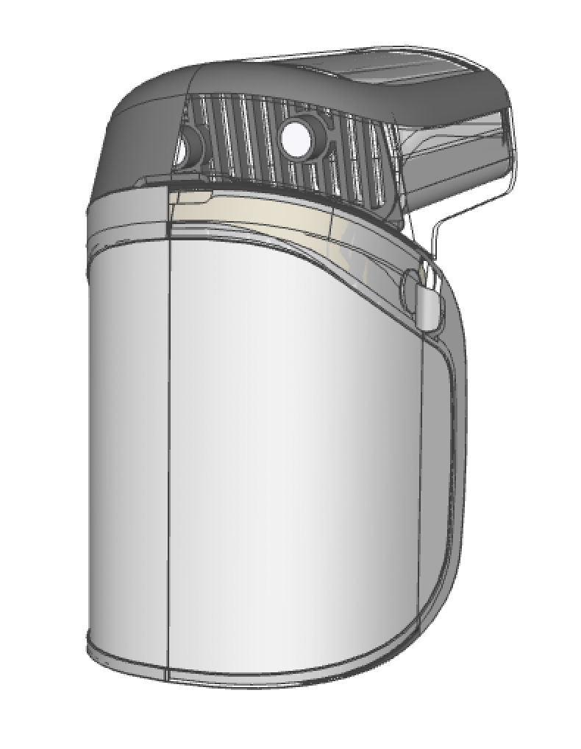

**Figure 1: CAD file of the original solution**

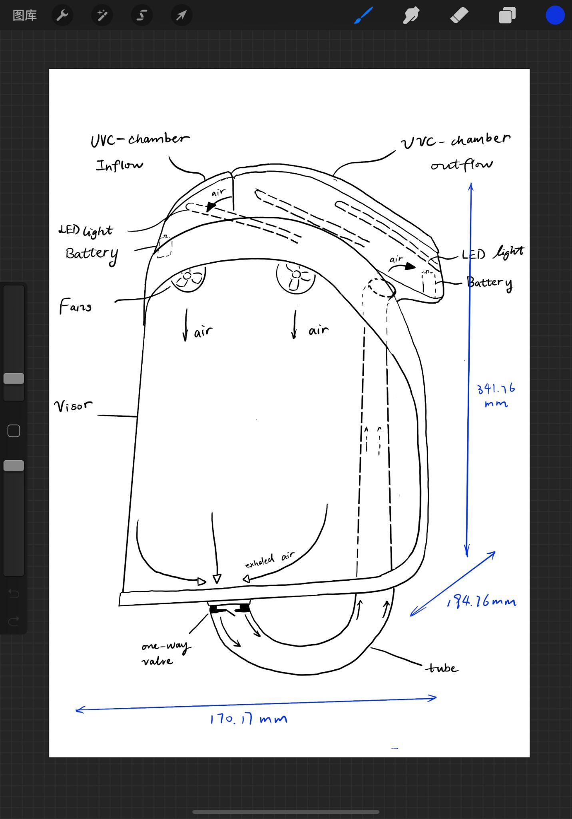

**Figure 2: Sketch of the final solution**

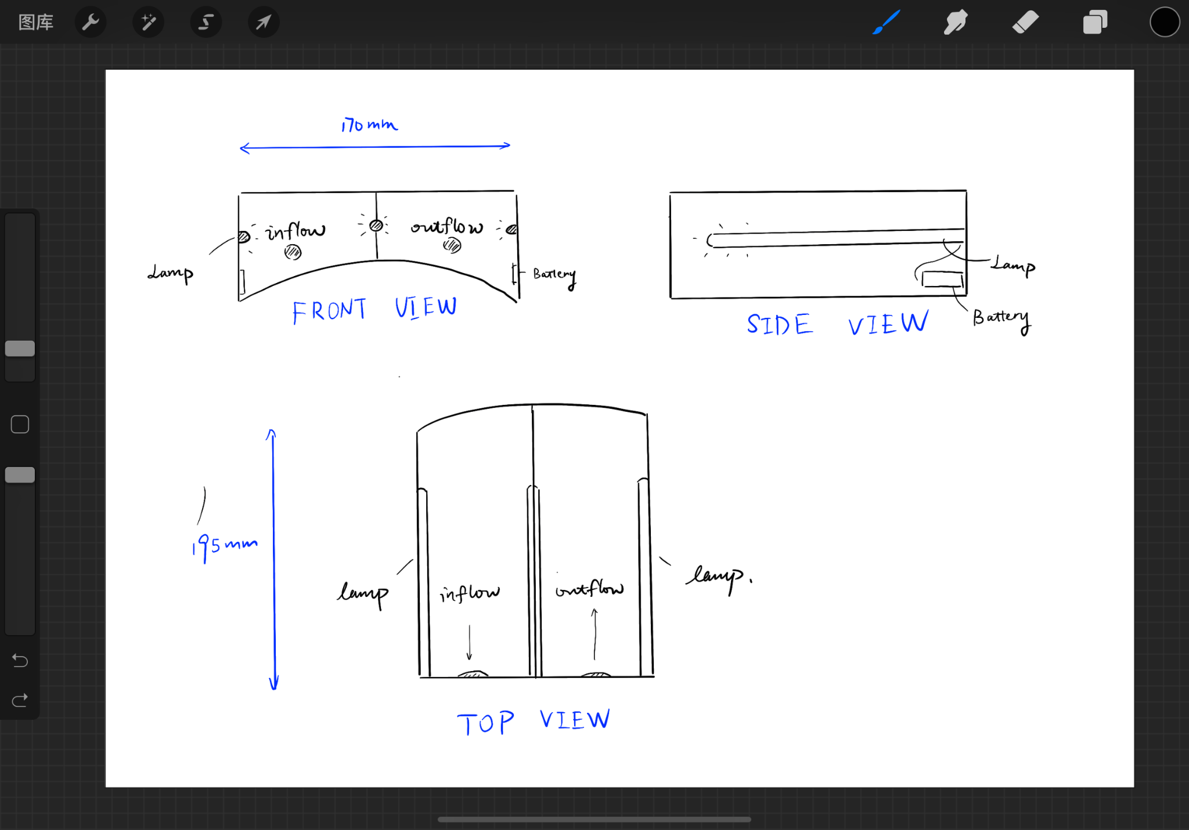

**Figure 3: Sketch of the UVC chamber**

**Plans for Prototyping the UltraVisor-C**

We decided to separate the prototyping of the UltraVisor-C into 3 phases of prototyping: low, medium, and high fidelity prototyping, and two phases of testing: one after the medium fidelity prototype and one after the high fidelity prototype.

Our low fidelity prototype (**Figure 4**) is a mockup to visualize the structure of the UltraVisor-C, made out of cardboard, tape, hot glue, and a thin plastic tube (**Table 1**). It is a small scale prototype, as shown in **Figure 4**, and the completed prototype can be seen in **Figure 5.** Through this small scale prototype, we are able to see how components should be attached to one another and how our additional modification will fit into the current UVisor design.

The medium fidelity prototype will be a full scale prototype based on **Figure 2 and 3**. It will have several 3D printed parts, a plastic tube, and working fans, but still use some cardboard components (**Table 1**). The UV-C chamber and frame of the mask will be 3D printed. However, we will make the divider in the UV-C chamber and the two ports of the tube out of cardboard, as these will need to be adjusted during testing. Furthermore, we will use a sheet of clear plastic for the visor, and a battery to power the fans. We will test this prototype by adjusting both the diameter of the tube and the placement of the divider in the UV-C chamber. This will help us determine what placement of the divider gives us a comfortable airflow for breathing both in and out, while minimizing the diameter of the tube. We will use smoke to visualize the airflow through the mask.

Finally, the high fidelity prototype will be full size and made of all 3D printed parts and have working fans and lamps (used to simulate and test how the UV-C light fills the chamber) (**Table 1, Figure 2, Figure 3**). We will test this prototype to determine whether the UltraVisor-C successfully achieves our goal of sanitizing the exhaled air. We will once again use smoke to visualize the airflow through the mask.

**Table 1: List of component parts**

| **Component** | **Material** | | |
| --- | --- | --- | --- |
| **Low Fidelity** | **Med Fidelity** | **High Fidelity** |
| UV-C Chamber | Cardboard | 3D printed plastic (divider and tube connection point made of cardboard) | 3D printed plastic |
| Face Shield Frame | Cardboard | 3D printed plastic (tube connection point made of cardboard) | 3D printed plastic |
| Face Shield Visor | None/Paper | Transparent vinyl sheet | Polyethylene terephthalate film |
| Tube | Plastic | Plastic | Plastic |
| Fan | Cardboard (only marked position) | 40mm x 40mm x 10mm DC fan | 40mm x 40mm x 10mm DC fan |
| LED Light Belt | Cardboard (only marked position) | Small LED (Bulbs) | 5.11 inches DC LED Belt |
| Battery | Cardboard (only marked position) | 9V Battery | 500mA Lithium Battery |
| One-way Valve | Hole cut by scissors | 0.59 inches (Diameter) valve | 0.59 inches (Diameter) valve |

**Reflections and Takeaways From Prototyping Design Plan for UltraVisor-C**

Our solution had several key features that determined what materials we decided to use in the different prototyping phases. The headpiece to be sturdy because it contains the UV lamps and holds together the rest of the UVisor, so we decided to use cardboard in the low and medium fidelity prototypes for the parts that we were testing and adjusting, and 3D printing in the medium and high fidelity prototypes for the parts that had been tested and finalized. This is because cardboard is sturdy enough to hold its shape, but is still easy to adjust while we are testing, while 3D printed plastic is much more sturdy and durable, but cannot be modified. We decided to leave off the visor in the low fidelity prototype and build the visor frame out of cardboard, since we are mainly testing the structure of the exhaled component. For the medium and high fidelity prototypes, we need to contain the air inside the visor to test airflow and also need something transparent to see if the visor fogs up. For the medium fidelity prototype, we will use transparent vinyl sheets, which are transparent and will hold air, but are cheap at the cost of being flimsy. For this reason, we will use a sturdier PET (polyethylene terephthalate) film for the high fidelity prototype, which is sturdier but more expensive. We decided to use flexible pneumatic tubes for all prototyping phases, since they are cheap and will carry air without leakage.

The biggest technical difficulty of developing our solution will be the addition of the tube and how we will ensure airflow to be directed back upwards through the tube. It’ll be difficult to figure out how thick the tube needs to be to ensure that most of the exhaled air goes through this tube. It’ll also be difficult to model whether or not air is actually going up through this tube and the effect on the inflow air that the user breathes in.

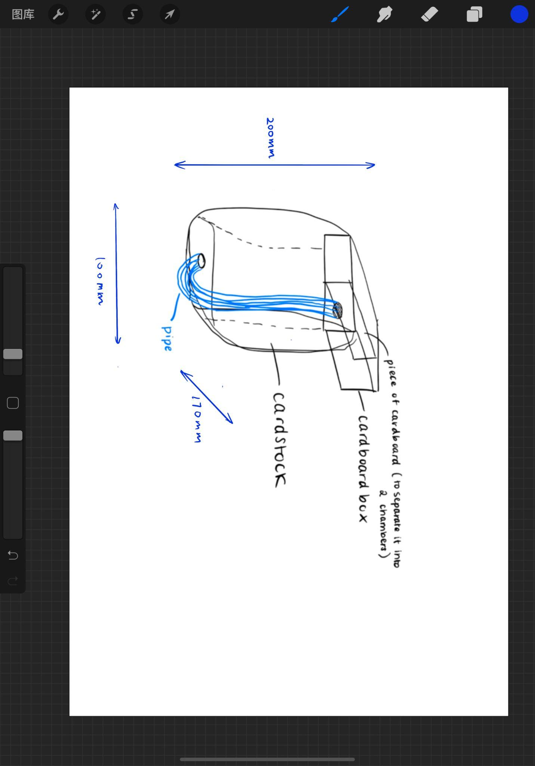

**Figure 4: Sketch of the low-fidelity prototype**

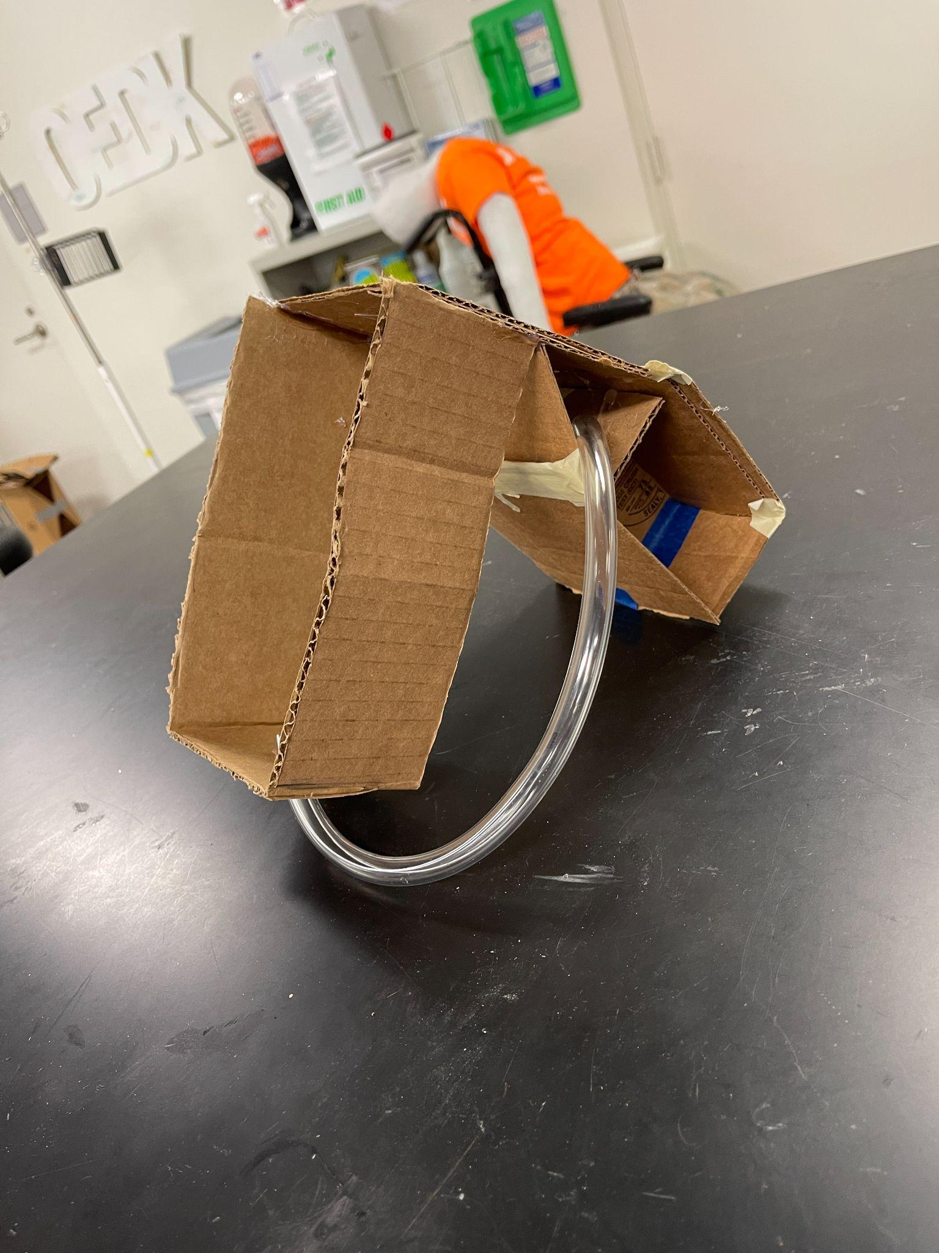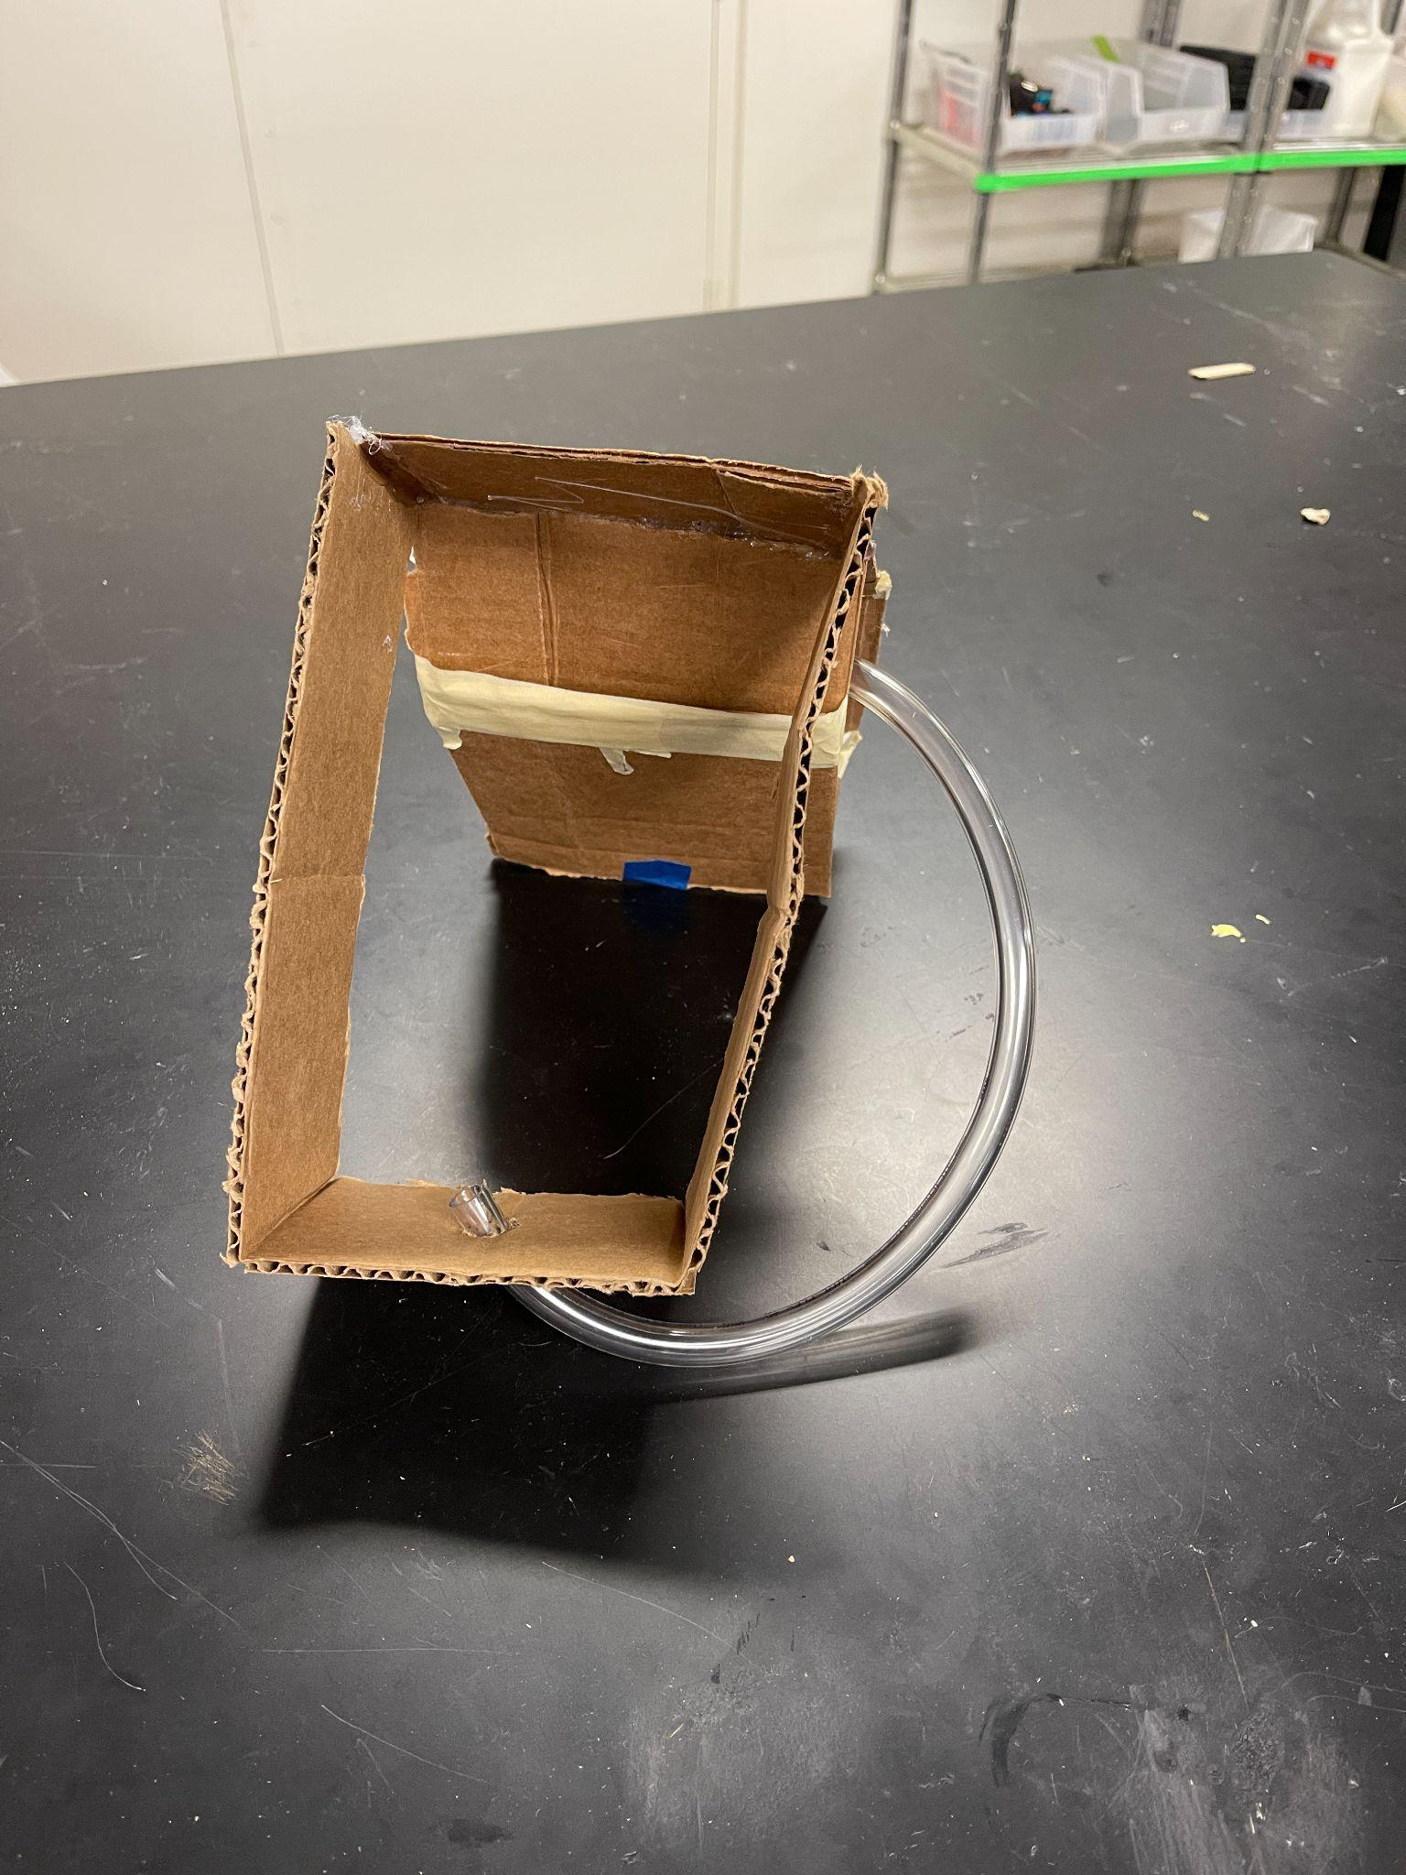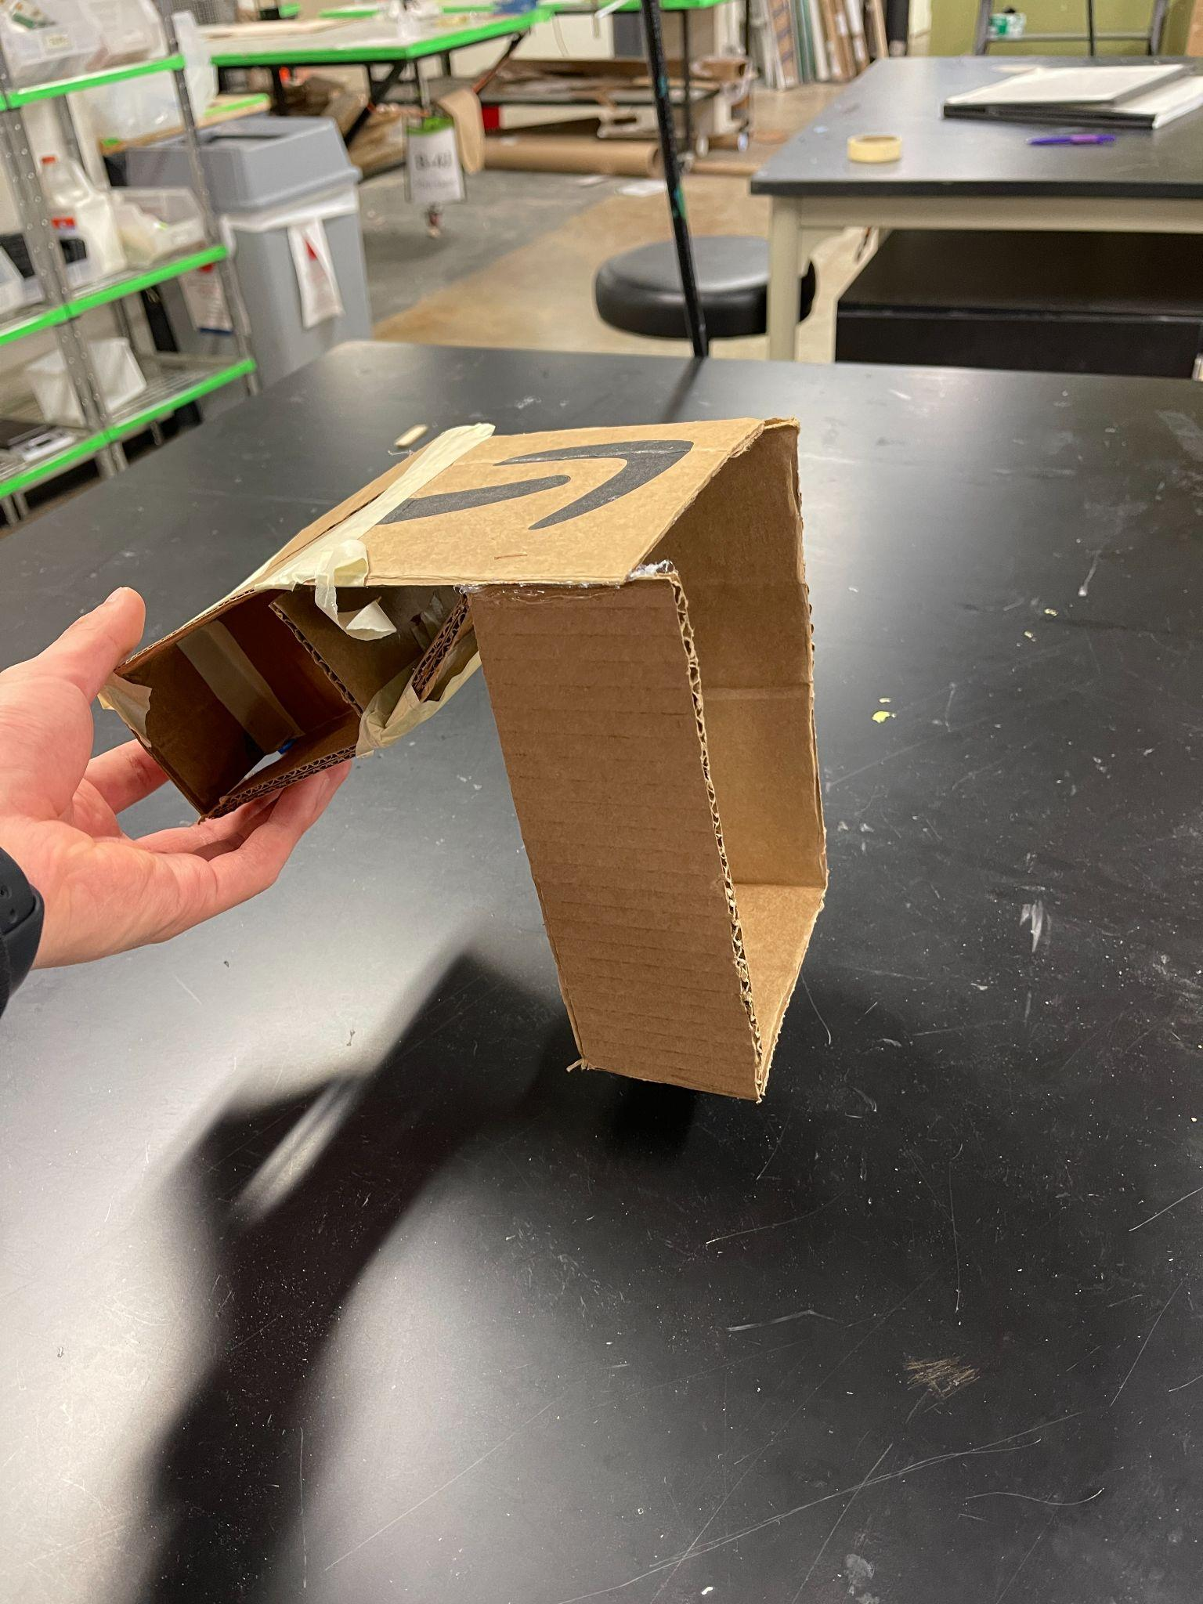

**Figure 5: Low-fidelity prototype (Viewed from Side, Front, Top)**